Chapter 01.06

Propagation of Errors

If a calculation is made with numbers that are not exact, then the calculation itself will have an error. How do the errors in each individual number propagate through the calculations. Let’s look at the concept via some examples.

Example 1
Find the bounds for the propagation error in adding two numbers. For example if one is calculating 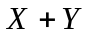where
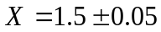,
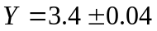 .

Solution
By looking at the numbers, the maximum possible value of X and Y are
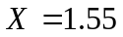 and 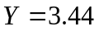
Hence
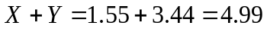
is the maximum value of 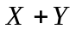.
The minimum possible value of X and Y are
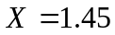 and 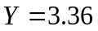.
Hence
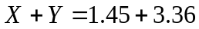
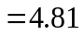
is the minimum value of .
Hence
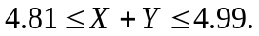

One can find similar intervals of the bound for the other arithmetic operations of 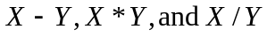. What if the evaluations we are making are function evaluations instead? How do we find the value of the propagation error in such cases.
If  is a function of several variables 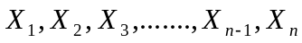, then the maximum possible value of the error in is
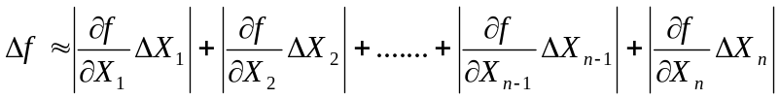

Example 2
The strain in an axial member of a square cross-section is given by
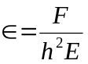
where
=axial force in the member, N
= length or width of the cross-section, m
=Young’s modulus, Pa
Given
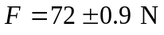
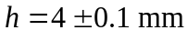
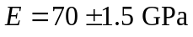
Find the maximum possible error in the measured strain.
Solution
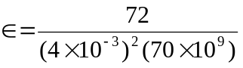
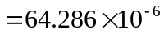
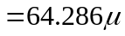
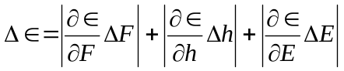
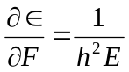
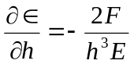
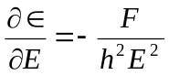
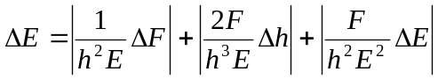
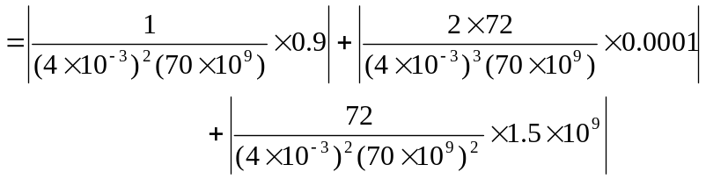
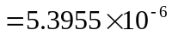
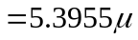
Hence
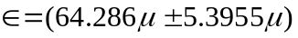
implying that the axial strain, is between 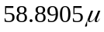 and 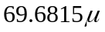

Example 3
Subtraction of numbers that are nearly equal can create unwanted inaccuracies. Using the formula for error propagation, show that this is true.

Solution
Let
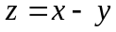
Then
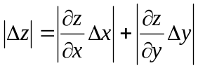
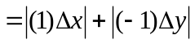
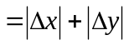
So the absolute relative change is
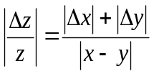
As and become close to each other, the denominator becomes small and hence create large relative errors.
For example if
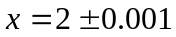
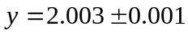
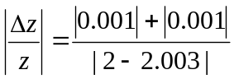
= 0.6667
= 66.67%

INTRODUCTION TO NUMERICAL METHODS
Topic | Propagation of Errors
Summary | Textbook notes on how errors propagate in arithmetic and function evaluations
Major | All Majors of Engineering
Authors | Autar Kaw
Web Site | http://numericalmethods.eng.usf.edu

